User Onboarding

Users  - Primary  - Newly registered users  - Secondary  - Admin in real communities  - Member in real communities | Phase 1
Intended Outcome
- Guiding newly registered users to successfully become either admin or member of communities
- …
Links
- …
- …
- …
- …
- …

Introduction
Kolavo as a community database only accepts real users to help community organizers having real members in their communities. Therefore, certain information and steps are required for users to provide which may confuse newly registered users as this may be uncommon for them and may lead to churn. For prevention, we want to provide easy to understand and motivating onboarding so they have the right expectation on what to do and keep using Kolavo to know who are in their communities.

Product Requirement
Flow of General Onboarding

Flow of Admin Onboarding

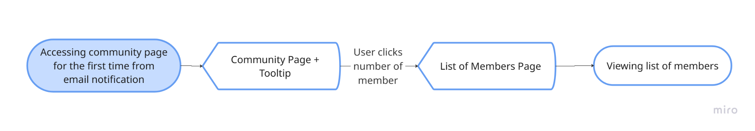
Flow of Member Onboarding

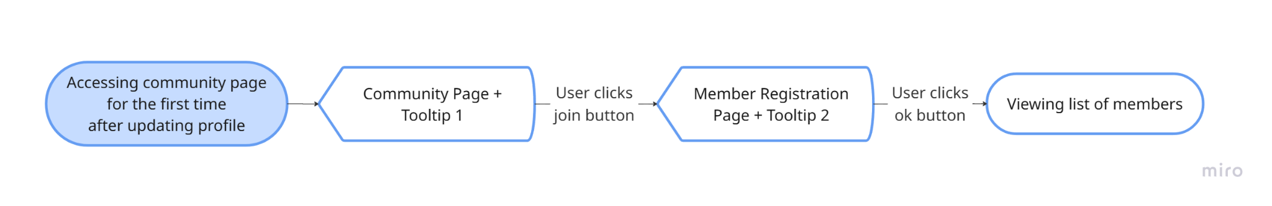
Flow of Member Registration Onboarding

No | User story | Scope | Acceptance Criteria
1 | As a newly registered user who are both organizers and members in different communities for real, I want to be told that it is possible in Kolavo, so I can create a community I manage and join as many communities as I have. | General users onboarding | - The onboarding starts after users sign up and login for the first time  - The first onboarding page is the account page.  - It covers in order:  - User profile: the importance of updating profile  - Create community: its function and location  - Community page: its function and location  - User’s list of communities: what kind of info will be shown there:result of publishing and joining communities.  - The onboarding ends when users click the update profile button.
2 | As a newly registered user who manages real communities, I want to know the requirements and steps to create my community, so I can do one. | Prospective Admin Create Community Page Onboarding | - This onboarding starts when the user clicks the create community page button for the first time.  - If the users haven’t updated their profile, modal shows to do so.  - Otherwise, users can access the page to create their community.
3 | As a newly registered user who successfully created a community, I want to know the requirements and steps to publish my community in Kolavo, so I can list one. | Admin Setup Membership Onboarding | - This onboarding starts from a newly created community page.  - It explains in order:  - Page states and its impact  - Ends as users click Atur Keanggotaan button
4 | As a newly registered user who successfully publishes a community, I want to be guided to register to and accept it in my own community, so I can be part of it. | Admin Application and Approval Onboarding | - This onboarding starts as a community page published.  - It explains in order:  - Joining to its own community  - Accepting its own application where it ends
5 | As a newly registered user who successfully publishes a community, I want to know how to use available features in the members page, so I can find members that I need. | Member Discovery for Admin Onboarding | - This onboarding starts as there is the first member joined.  - It explains in order:  - Number of Member  - Chips  - Filter  - Tag  - Note  - Member card  - It ends as the user closes it at the member card explanation.
6 | As a newly registered user who is part of communities in real life, I want to know the requirements and steps to join a community in Kolavo, so I can be part of it. | Prospective Member Join Community Onboarding | - This onboarding starts when the user clicks the join or number of member buttons after login for the first time.  - If the users haven’t updated their profile, modal shows to do so.  - Otherwise, users can proceed to member registration.
7 | As a newly registered user who just became a member of a community, I want to know how to use features in members' pages, so I can find my community mates. | New Member Onboarding | - This onboarding starts as a user is accepted to a community.  - It first happens by a user receiving an email notification which invites the user to see its community member.  - Then the app displays the community page which shows in order:  - Number of Member  - Chips  - Filter  - Tag  - Note  - Member card  - It ends as the user closes it at the member card explanation.

Design Requirement

General Users Onboarding
Design Intent | To guide newly registered users about the importance of updating profile, where to create, see listed and their communities, and make them update their profiles.
Content / Copy | - Tooltip 1 - User profile: the importance of updating profile  - Selamat datang! Kamu sedang berada di halaman profil kamu.  - Next button  - Tooltip 2 - Create community: its function and location  - Kalau profil kamu sudah lengkap, kamu bisa bikin halaman komunitas kamu disini.  - Next button  - Tooltip 3 - Community page: its function and location  - Disini, kamu juga bisa cari dan gabung ke komunitas yang sudah ada.  - Next button  - Tooltip 4 - User’s list of communities: what kind of info will be shown there:result of publishing and joining communities.  - Semua komunitas yang kamu punya, akan muncul disini. Ayo mulai perbarui profil kamu.
Visual Requirement | - Show in tooltips where the tail point to each target:  - User profile  - Create community button  - Communities button  - List of communities
Interaction Behavior | - Tooltips closes as user click Ubah Profile
Acceptance Criteria

Admin Onboarding

Setup Membership Onboarding
Design Intent | To guide new admin to setting membership up so its community page can be published
Content / Copy | - Tooltip 1 - At the state:  - Halaman komunitas belum diterbitkan karena pendaftaran belum dibuka. Klik Atur Keanggotaan untuk mengatur keanggotaan dan membuka pendaftaran anggota.
Visual Requirement | - Show in tooltips where the tail point to community page state
Interaction Behavior | - Bubble closes as user click Atur Keanggotaan
Acceptance Criteria

Application Onboarding
Design Intent | To guide admins joining into their own community
Content / Copy | - Tooltip 2 - At the join button:  - Apakah kamu anggota dari komunitasmu? Ayo klik Gabung dan lakukan pendaftaran agar keanggotaan mu juga diperhitungkan.
Visual Requirement | - Tooltips points to join button
Interaction Behavior | - Tooltips ends as user clicks join button
Acceptance Criteria

Approval Onboarding
Design Intent | To guide admins accepting their own application within their own community
Content / Copy | - Tooltip 3 - At the incoming application:  - Ada pendaftaran masuk! Ayo periksa dan proses pendaftarannya.
Visual Requirement | - Join tooltip points to incoming application
Interaction Behavior | - Join tooltip ends as user clicks applicant card
Acceptance Criteria

Member Discovery Onboarding
Design Intent | To guide admins exploring their members in their communities as they have
Content / Copy | - Tooltip 4 - Number of Member:  - Lihat! Sekarang kamu punya anggota. Klik untuk melihat daftar anggotamu.
Visual Requirement | - Tooltips points at Number of member
Interaction Behavior | - Tooltips disappear as user clicks number of member
Acceptance Criteria

Member Onboarding

Prospective Member Onboarding
Design Intent | To guide newly registered user how to join community
Content / Copy | - Tooltip 1 at join button:  - Selamat datang! Ayo gabung biar bisa kenal dengan sesama anggota komunitasmu.
Visual Requirement | - Tooltip points at join button
Interaction Behavior | - Tooltip disappears as user clicks join button
Acceptance Criteria

Registration Member Onboarding
Design Intent | To make users understand about how the data they input will be valuable and private to their community
Content / Copy | - Tooltip 2 at registration form :  - Informasi yang kamu berikan hanya dilihat oleh pengurus untuk verifikasi keanggotaan. Jika kamu diterima, kamu akan dikenal oleh sesama anggota komunitas.  - Ok button: Mengerti.
Visual Requirement | - Tooltip points at registration form
Interaction Behavior | - Tooltip disappears as user clicks Ok button
Acceptance Criteria

Member Discovery for New Member
Design Intent | To guide new members exploring their fellow members
Content / Copy | - Tooltip at Number of Member:  - Selamat datang! Lihat siapa saja yang sesama anggota disini.
Visual Requirement | - Tooltip points at Number of member
Interaction Behavior | - Tooltip disappears as user clicks number of member
Acceptance Criteria

Engineering Requirement

Questions

